https://community.turing.com/events/details/turing-latin-america-events-presents-jump-start-2022-10-18/

https://www.turing.com/blog/turing-developer-test-preparation-tips/

https://community.turing.com/events/details/turing-latin-america-events-presents-jump-start-2022-10-18/

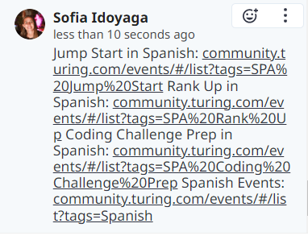
https://community.turing.com/events/#/list?tags=SPA%20Rank%20Up
https://community.turing.com/events/#/list?tags=SPA%20Coding%20Challenge%20Prep
https://community.turing.com/events/#/list?tags=SPA%20Jump%20Start
https://community.turing.com/events/#/list?tags=Spanish
https://help.turing.com/hc/en-us/articles/360004371156-What-is-Turing-s-vetting-process-
